Assignment two: Researcher
Teaching and learning in the digital age.
Topic: Using technology to improve Mathematic skills in the classroom.
Technology has become an essential tool for learning Mathematics in the 21st century. With the rapid development of high quality “user friendly” Mathematics technology, it is becoming more apparent in the classrooms of schools today. Teachers are gradually learning how to modify both the Mathematical content of their curriculum and their approach to teaching to take full advantage of the new available technology to assist with the teaching of Mathematics. Adapting the available technology to the education of Mathematics is an effective tool that assists in the development of students’ understanding, captures their engagement and increases their proficiency in mathematics. The following five resources explore how technology is being used to effectively teach mathematics in a school environment.
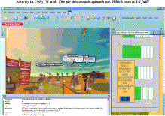
Journal Article- Utilising a Collaborative Macro-Script to Enhance Student Engagement: A mixed method study in a 3D Virtual Environment.
This article examines the effect of using an online 3D virtual environment in teaching Mathematics in Primary Education. The focus of the researched project is to examine the student’s engagement and understanding of the Maths topics, in comparison to the existing teaching methods of Mathematics, to enhance collaborative learning. The research was carried out over four teaching sessions in a primary school classroom, which involved a purposely created 3D virtual environment that included learning tasks related to basic fractions.
(H Bouta, S Retalis, & F Paraskeva, 2012)

Data collected in comparison of the effect the 3D virtual environment created, included classroom observation notes, results from pre-and-post tests, and chat logs. Research presented indicates that students had more enthusiasm and interest towards the 3d virtual environment. This in turn results in a higher level of student engagement in the collaborative learning process. (H Bouta, S Retalis, & F Paraskeva, 2012)
Book- Teaching Mathematics Using ICT
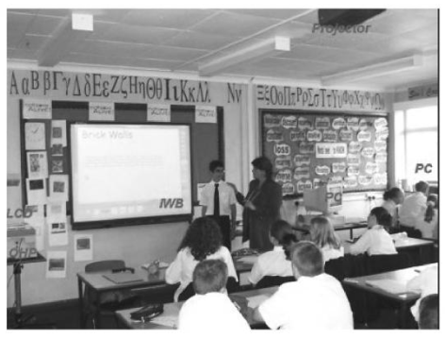
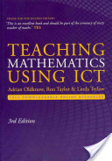
Online Maths programs and existing technology tools such as the interactive white board are valuable resources available for teachers. The book ‘Teaching Mathematics Using ICT’ informs teachers of how they can apply technology to cover a variety of Maths topics. The book discusses a mathematical concept, and then creates suggestions as to how teachers can use technology to effectively teach the topic at hand. The author has also included a guide as to where teachers can find the best free resources. (Oldknow, Taylor, & Tetlow, 2010)
(Oldknow, Taylor, & Taylor, 2010)

YouTube Videos- envision MATH, and Teacher Reports Nearly 50% Increase in A’s and B’s
Envision MATH, and Teacher Reports Nearly 50% Increase in A’s and B’s are two videos that explore a digital path of teaching maths skills with Pearson’s innovative envision MATH. The program envisions MATH incorporates the use of animation, a visual learning bridge and an innovative instruction model, to support students in their learning of Mathematics. (PearsonEducation, 2009) Jennifer Winkler from Rane Lowe Elementary school in Pflugerville states that her students Maths skills have improved greatly recording a 50% increase in A’s and B’s in her classroom. (TexasCurriculum, 2011)

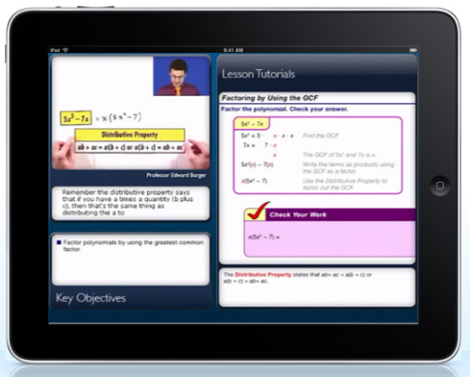
Website- Houghton Mifflin Harcourt, HMH fuse.
HMH fuse website provides information on the first education app program for schools, developed exclusively for a touch screen mobile device. Houghton Mifflin Harcourt has designed the available apps ‘HMH fuse for Geometry’ and ‘HMH fuse for Algebra.’ These revolutionary apps combine direct instructions, support, assessments, and intervention which allow teachers to personalise instructions.
("Houghton mifflin harcourt," 2012)
("Houghton mifflin harcourt," 2012)

Conference paper- Combining Various Technologies in Effective Online Math Instruction - A Nationwide Secondary Level Maths Project.
A researched study undertaken by Wroclaw University of technology involving an educational project called ‘Mathematics – Reactivation.’ The purpose of this project is to provide secondary schools with a complete e-course in mathematics covering the whole maths curriculum. This was developed due to a demand for further teaching support and a paucity of quality maths instructions. The research study involves a sophisticated system of regular electronic testing; results are stored in a database and later processed statistically. As a result, participating schools received an interactive method in contrast to the traditional teaching process. In conclusion the e-learning solutions that had initially been implemented have now been enhanced and a variety of technologies have been combined. (Kajetanowicz & Wierzejewski, 2011)

Reference List:
Bouta, H., Retalis, S., & Paraskeva, F. (2012). Utilising a collaborative macro-script to enhance student engagement: A mixed method study in a 3D virtual environment. Screenshot from the cosy_world experience from http://www.sciencedirect.com/science/article/pii/S0360131511002090
Bouta, H., Retalis, S., & Paraskeva, F. (2012). Utilising a collaborative macro-script to enhance student engagement: A mixed method study in a 3D virtual environment Computers and Education 58(1), 501-517.
. Houghton mifflin harcourt. (2012). HMH fuse from http://www.hmheducation.com/fuse/educational-apps-overview.php
Kajetanowicz, P., & Wierzejewski, J. (2011). Combining various technologies in effective online math instruction - a nationwide secondary level maths project. . Paper presented at the 14th International Conference on Interactive Collaberative Learning, Wroclaw Poland.
Oldknow, A., Taylor, R., & Taylor, R. (2010). Teaching mathematics using ict, from http://books.google.com.au/books?id=w7T8XJu4ot0C&printsec=frontcover&dq=teaching+mathematics+using+ict&hl=en&sa=X&ei=fPicT7-DKMPPmAXq5Z2bDg&redir_esc=y#v=onepage&q=teaching%20mathematics%20using%20ict&f=false
Oldknow, A., Taylor, R., & Tetlow, L. (2010). Teaching mathematics using ict (3rd ed.). Great Britain: Continuum International Publishing group.
PearsonEducation. (2009). Teacher reports nearly 50% increase in a's and b's, from http://www.youtube.com/watch?v=4DYGAujfxeo
TexasCurriculum. (2011). Envision maths, from http://www.youtube.com/watch?v=J1eyQcTK4Sg&feature=related

